**Input and Output Problems (String and Numeric Variables)**

**Task 1:**

**Plan:**

1. Accurate user input validation, with error messages.
2. Print variables.

**Pseudocode:**

Age 🡸 None

While age = None:

Try:

age 🡸 input as integer (“How old are you”)

name 🡸 input (“What is your name”)

tv 🡸 input (“What is your favourite TV program”)

except:

print (“That is not a valid age”)

print (name, ”is” ,”Years old and likes”, tv)

**variables table:**

|  |  |  |
| --- | --- | --- |
| Variable Name | Variable type | Variable value |
| age | Integer | Stores input from user |
| name | String | Stores input from user |
| tv | String | Stores input from user |

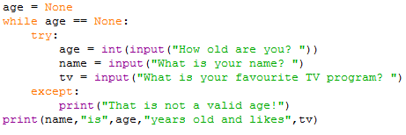**Screenshot evidence:**

In this screenshot I have while loop that validate the user input, and a print statement to print the users input.

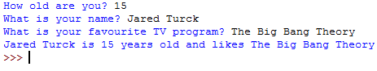**Sample run (Output):**

In the above screenshot is a sample run of the code, as you can see the program asks the users 3 questions, then outputs there answer in a sentence.

**Testing table:**

|  |  |  |  |
| --- | --- | --- | --- |
| What am I testing | Input | Expected output | Actual output screenshot |
| Checks validation of the while loop by entering a value that is not an integer | “one”  15.94 | Error message  Error message |  |

**Flow charts:**

**START**

Age 🡸 input as integer

Is age an integer?

**END**

print (name, age, tv)

tv 🡸 input (“What is your favourite TV program”)

name 🡸 input (“What is your name”)

NO

Output error message